

**Citizen Review Access System Using Python and Flask**



**Name:** Vaibhav Dubey

**Class:** MCA 2nd Year

**H.T. No:** 1251-22-862-024

**Year:** 2022-24

WESLEY POST GRADUATE COLLEGE

**Abstract**

**Title**

Citizen Review Access System Using Python, Flask, Jinja and HTML 5

Effective governance hinges on understanding and responding to citizen needs. In today's digital age, online platforms offer innovative avenues for collecting and analyzing public feedback on government policies. This project presents the development of a web application designed to assess citizen feedback on government policies, enabling policymakers to make informed decisions that resonate with the public. Leveraging the power of web technologies, the application fosters open communication and participation, bridging the gap between the government and its constituents.

The mini college project, "Assessing Citizen Feedback on Government Policies," leverages a comprehensive technology stack comprising HTML, CSS for the frontend, coupled with Python and Flask for the backend. This interdisciplinary approach facilitates the creation of an interactive platform aimed at collecting, analysing, and presenting valuable feedback from citizens regarding government policies. The project not only addresses the technological challenges of web development but also delves into the realms of civic engagement and governance.

**Introduction**

Governments grapple with the challenge of crafting policies that cater to the diverse needs and aspirations of their citizens. Traditionally, feedback was gathered through limited channels like public hearings, town halls, and surveys. However, these methods often suffer from low participation rates, limited reach, and potential biases. The surge in internet usage has opened doors for new approaches to citizen engagement. Interactive web applications provide a dynamic platform for collecting and analysing public opinion, offering valuable insights into policy effectiveness and areas of concern.

In an era where citizen participation is crucial for effective governance, harnessing technology to gather and analyse feedback becomes imperative. The project aims to bridge the gap between citizens and policymakers by providing an accessible and user-friendly platform for expressing opinions on government policies. By combining frontend technologies (HTML, CSS) for an intuitive user interface and backend technologies (Python with Flask) for data processing, the project endeavours to enhance civic engagement.

**Existing System**

Traditionally, citizen feedback mechanisms rely on physical town hall meetings, surveys, or limited online forms. These methods often face challenges such as low participation rates, time constraints, and difficulties in aggregating and analysing diverse responses. The existing system lacks a unified and efficient approach to collect comprehensive feedback, hindering the government's ability to make informed decisions that align with public sentiment.

In many countries, the existing systems for collecting feedback on government policies remain traditional and passive. Reliance on outdated methods like written submissions, phone calls, and physical attendance at meetings restricts participation and limits the scope of feedback. These methods are often time-consuming, resource-intensive, and prone to logistical bottlenecks. Furthermore, analysing the accumulated data through manual means can be cumbersome and inefficient, hindering actionable insights for policymakers.

**Proposed System**

This project addresses these limitations by proposing a robust and user-friendly web application built with HTML, CSS for the front-end and Python with Flask for the back-end. The application streamlines the feedback process by offering an intuitive interface where citizens can easily register, access policy information, and submit their opinions. Interactive features like forums, discussion threads, and surveys allow for in-depth feedback and nuanced understanding of public sentiment.

The proposed system revolutionizes the process of collecting citizen feedback by offering a dynamic and accessible online platform. The front-end, developed using HTML, CSS, provides an engaging and responsive interface for users to navigate effortlessly. The back-end, powered by Python and Flask, ensures secure data handling, storage, and efficient processing of citizen feedback.

The system allows citizens to express their opinions on specific government policies through user-friendly forms and interactive features. Additionally, the platform incorporates data visualization tools to present the feedback in an understandable format for policymakers. This approach enhances the transparency and efficiency of the feedback collection process.

**Modules**

* Data Collection
* Data Storage
* Data Review

**System Requirements**

The successful implementation of the project requires specific system components and configurations. On the frontend, modern web browsers supporting HTML5 and CSS3 are essential for optimal user experience. JavaScript, being a client-side scripting language, enhances interactivity. On the backend, Python 3.x with Flask is utilized for server-side logic, data processing, and communication with the frontend. Additionally, a relational database system, such as SQLite, is employed for efficient data storage and retrieval. The system is designed to be platform-independent, ensuring accessibility across diverse devices and operating systems.

**Requirements:**

* **Hardware Requirements:**

1. **System:** Intel I3 or AMD Ryzen 3
2. **Hard Disk:** 500 GB
3. **RAM:** >=4 GB

* **Software Requirements:**

1. **Operating System:** Windows
2. **Coding Language:** HTML, CSS, Python and Frameworks like Bootstrap and Flask

**Conclusion**

In conclusion, the project "Assessing Citizen Feedback on Government Policies" introduces an innovative approach to bridge the gap between citizens and government entities. The utilization of HTML, CSS ensures a user-friendly front-end experience, while Python with Flask handles the backend operations efficiently. This system has the potential to revolutionize the way governments gather and analyse citizen feedback, fostering a more participatory and transparent democratic process.

By embracing modern web technologies, this project contributes to the evolution of civic engagement, empowering citizens to actively participate in shaping government policies. The dynamic nature of the platform, coupled with the robust back-end architecture, positions it as a valuable tool for policymakers seeking genuine and diverse perspectives from the communities they serve.

This project marks a significant step towards enhancing citizen engagement and fostering informed government decision-making. By harnessing the power of web technologies, the proposed application bridges the gap between citizens and policymakers, empowering the public to have a meaningful voice in shaping their governance. The real-time feedback mechanism and transparent data visualization tools aim to cultivate a culture of open communication and responsive governance, ultimately leading to policies that better reflect the needs and aspirations of the people.

**Index**

**Introduction** 7

Overview of Citizen Review Access System 7

Digital Technology for Citizen Empowerment 8

Feedback Loop 9

Success Factors for Feedback 10

**Scopes and Objectives** 12

Scope 12

Objectives 12

Simple Service Feedback System 13

Advantages 15

**System Analysis** 17

**Software Requirements** 19

**Technology** 20

Python 20

Flask 21

HTML 5, CSS 3 and Bootstrap 5 22

Jinja Templating 24

**The Look and the Flow** 25

The Look 25

The Flow 26

**Conclusion** 27

**References 27**

Official Documentations 27

# **Introduction**

## **Overview of Citizen Review Access System**

Effective governance hinges on understanding and responding to citizen needs. In today's digital age, online platforms offer innovative avenues for collecting and analysing public feedback on government policies. This project presents the development of a web application designed to assess citizen feedback on government policies, enabling policymakers to make informed decisions that resonate with the public. Leveraging the power of web technologies, the application fosters open communication and participation, bridging the gap between the government and its constituents.

Governments grapple with the challenge of crafting policies that cater to the diverse needs and aspirations of their citizens. Traditionally, feedback was gathered through limited channels like public hearings, town halls, and surveys. However, these methods often suffer from low participation rates, limited reach, and potential biases. The surge in internet usage has opened doors for new approaches to citizen engagement. Interactive web applications provide a dynamic platform for collecting and analysing public opinion, offering valuable insights into policy effectiveness and areas of concern.

In an era where citizen participation is crucial for effective governance, harnessing technology to gather and analyse feedback becomes imperative. The project aims to bridge the gap between citizens and policymakers by providing an accessible and user-friendly platform for expressing opinions on government policies. By combining frontend technologies (HTML, CSS) for an intuitive user interface and backend technologies (Python with Flask) for data processing, the project endeavours to enhance civic engagement.

Traditionally, citizen feedback mechanisms rely on physical town hall meetings, surveys, or limited online forms. These methods often face challenges such as low participation rates, time constraints, and difficulties in aggregating and analysing diverse responses. The existing system lacks a unified and efficient approach to collect comprehensive feedback, hindering the government's ability to make informed decisions that align with public sentiment.

In many countries, the existing systems for collecting feedback on government policies remain traditional and passive. Reliance on outdated methods like written submissions, phone calls, and physical attendance at meetings restricts participation and limits the scope of feedback. These methods are often time-consuming, resource-intensive, and prone to logistical bottlenecks. Furthermore, analysing the accumulated data through manual means can be cumbersome and inefficient, hindering actionable insights for policymakers.

## **Digital Technology for Citizen Empowerment**

Improving the quality, impact, and efficiency of public services is one of the most critical challenges of public policy. There are multiple ways of addressing these challenges, but a common theme is the need to put citizens at the center of governance and service delivery through:

(i) Empowerment: putting citizens at center of service provision and incentivizing delivery.

(ii) Transparency — openness and sharing of information.

(iii) Accountability — enabling citizens to monitor service levels and quality; and

(iv) Participation — including citizens in policy design and implementation.

**CFS Goals:**

· Substantially reduce corruption and bribery in all their forms.

· Develop effective, accountable, and transparent governance at all levels.

· Ensure responsive, inclusive, participatory, and representative decision-making at all levels.

The growing use of digital technologies, including mobile connectivity and the internet, offers new opportunities to institute a range of scalable feedback mechanisms that are far faster and probably less costly, than traditional approaches. Rapid, more granular, feedback can help in the early design phases as well as in the reform of legacy systems where major redesign may be costly. Bottlenecks can be alleviated, and accountability improved, often without the need to fully replace the system.

Some nongovernmental organizations (NGOs) have pioneered efforts to build on digital technology to strengthen citizen feedback, and many governments have taken steps to incorporate the use of digital technology, including payments, into service delivery. However, few government programs have yet harnessed the potential of the vast amount of information generated by digital systems to assess service quality and empower citizens. This note considers the potential of digital technologies to support these goals by facilitating feedback and empowering users.

## **Feedback Loop**

A feedback loop is any mechanism that generates information on the quality of service. Once collected, this information can be used to improve performance. The service delivery chain starts with a request by the citizen and ends with delivery by the service provider. A feedback loop can start collecting information at any point in the delivery chain (see below). The administrative data loop collects information on individual service transactions (for example, the number of days between request for service and delivery for every transaction), while the choice and voice loop collect data on the service experience of the citizen (for example, satisfaction with the experience). The collected data can then be used to measure service levels, gauge user satisfaction, and diagnose problems.

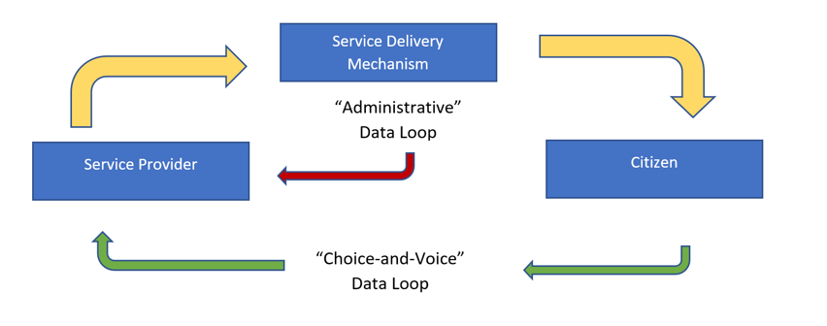

Digital feedback loops can be more than a computerized version of existing analog processes. By leveraging technology, they enable the collection of large volumes of data in almost real time, including crowdsourcing suggestions and ideas at the planning stage. Data collection and analysis can be far timelier and more transaction-specific than that from retrospective audits based on paper-based records or periodic field surveys. Reporting costs and burdens can be eased by using a range of response modalities, including text messages and robocalls. Handheld voting devices and audience response systems can offer individuals the opportunity to express their views while preserving their anonymity and ensuring that the opinions are submitted by genuine clients.

Digital feedback loops can be more than a computerized version of existing analog processes. By leveraging technology, they enable the collection of large volumes of data in almost real time, including crowdsourcing suggestions and ideas at the planning stage. Data collection and analysis can be far timelier and more transaction-specific than that from retrospective audits based on paper-based records or periodic field surveys. Reporting costs and burdens can be eased by using a range of response modalities, including text messages and robocalls. Handheld voting devices and audience response systems can offer individuals the opportunity to express their views while preserving their anonymity and ensuring that the opinions are submitted by genuine clients. Speed is a great benefit. On the user side, rapid feedback and response is important to encourage further involvement. On the provider side, more timely information, including from administrative data, can help to correct shortcomings while preempting frequent bureaucratic obfuscations to ex-post audits—that the problems exposed are old ones; that they had been recognized before the audit; and that corrective action has already been taken.

## **Success Factors for Feedback**

As for other areas of technology, digital feedback mechanisms are only tools. The enabling environment, design, incentives to participate, and the motivation and capacity to respond are critical to the success of any feedback loop.

**Commitment:** Feedback systems will have little impact in cases where there is no high-level commitment to improve service delivery or inadequate resources and capacity to respond. If adverse feedback is treated as a sign of individual or organizational failure, it will probably be suppressed. High-level political leadership should convey a clear message to both providers and clients that feedback is valued, and its relevance should be demonstrated by visible improvements in service quality. Commitment can be demonstrated by linking feedback levels to incentives for service providers. At the same time, delivery agents need to be brought on board while putting in place performance metrics and incentives for better service, especially when, as is likely, reduced bureaucratic discretion constrains opportunities for diversion and corruption, enhancing resistance to change.

**Transparency:** The transparency of feedback to all stakeholders, both internal and external, can help to avoid the suppression of negative information and can also be taken as a signal of commitment. Transparency should extend to information on the resolution times for complaints.

**Learning:** Going beyond grievance redressal, learning organizations put in place processes to analyze information, identify actionable improvements in business processes, and shape the long-term service design approach. This objective becomes more feasible with the large real-time data sets generated through digitized transactions coupled with tools such as data analytics.

**Accessibility and safeguards:** Even though digitized systems can reduce transaction costs for many people, they can also raise barriers for others. Requiring access to mobile data or the internet can exclude the poor and marginalized, biasing the distribution of feedback providers. Cultural norms (including gender), language abilities, and literacy levels can also constrain access. To overcome these capacity and resource challenges, digital feedback loops can allow feedback to be sent through trusted intermediaries (including reputable NGOs) as well as directly by citizens. Data analysis can also help reconcile privacy concerns with the need to provide metrics of service performance.[3]

**Choice, voice, and control:** Corrective action can be in the hands of the service provider or of the citizens themselves. In provider-controlled systems, feedback can form the basis for corrective action only if the service provider chooses to do so. In citizen-controlled systems, consumers are empowered to take action, including by changing their service provider. While portability across service providers may not always be practicable (in sparsely serviced areas, for example), it provides a powerful signal by fostering competition among delivery agents.

**Proactivity:** In passive systems, citizens must initiate the feedback process; in active systems, the service provider (including the government) reaches out for feedback. Systems can involve a combination of active and passive — for example, automated post-service calls to all clients (followed by selective follow-up for those not satisfied with service) combined with passive feedback through a toll-free telephone number or website.

**Richness:** Feedback can range from a simple number code (SMS 1 for yes, 2 for no) to a text message to richer media, such as audio or video files. Increasingly, social media (Facebook, Twitter) and messaging platforms (WhatsApp) enable rich feedback; they have become powerful interfaces between citizens and states. Increased digital capacity in public systems signals a richer range of options in the future, with corresponding opportunities for learning and improving the delivery mechanism.

# **Scopes and Objectives**

## **Scope**

India has become a laboratory for digitization, with reforms to a wide range of services and benefit programs. Two recent cases offer insights into the use of feedback mechanisms.

1. Consumer Choice and Voice in India’s LPG Cooking Gas Subsidy Reform:

2. The state of Andhra Pradesh (AP) in southern India has emerged at the vanguard of using technology to reform service delivery, with generally good results as indicated by beneficiary and user surveys. Together with the principle of universal access—efforts to make Aadhaar available to all 50 million people and to integrate it into all programs and administrative departments — AP’s approach has stressed the principle of clear accountability to rectify cases of technology failure. At local levels, each community has a Village Revenue Officer (VRO), the lowest level of the administrative service who is authorized to deal with public resources and payments. These VROs are mandated to deal with the (very few) exceptions and cases of technology failure, ensuring that the digital reforms do not lead to exclusion of genuine beneficiaries.

**Conclusion to Take Charge:**

Real-time digital analysis of customer search and transaction patterns, including reviews, is increasingly being used in the commercial world. Star ratings on Amazon for sellers are ubiquitous; as are Uber ratings for drivers and passengers. Airports increasingly follow Singapore’s precedent, with passengers invited to punch a button with a smiley or frowny face; there are also thought-provoking examples from the NGO world.

Real-time feedback loops are still rare for government programs but are becoming more feasible as countries transition towards digitized delivery mechanisms. They offer several advantages: scalability, transparency, granularity to the level of individual transactions, and the ability to drive corrections and adjustments through data analytics. Above all is their ability to operate in real time, to support the “short route” to improving the efficiency and responsiveness of public service delivery.

## **Objectives**

The CFRS platform is a cloud-based citizen feedback system for government service providers. This is a simple and easy-to-adapt digital platform to empower citizens and help government service providers constantly monitor and improve service quality.

The proposed system revolutionizes the process of collecting citizen feedback by offering a dynamic and accessible online platform. The front-end, developed using HTML, CSS, provides an engaging and responsive interface for users to navigate effortlessly. The back-end, powered by Python and Flask, ensures secure data handling, storage, and efficient processing of citizen feedback.

The system allows citizens to express their opinions on specific government policies through user-friendly forms and interactive features. Additionally, the platform incorporates data visualization tools to present the feedback in an understandable format for policymakers. This approach enhances the transparency and efficiency of the feedback collection process.

## **Simple Service Feedback System**

**Step 1: Define the Objectives**

Determine the specific goals and objectives of the feedback system. Clarify what you want to achieve with the collected data, such as improving service quality, identifying areas for improvement, and enhancing citizen satisfaction.

**Step 2: Design the Feedback Form**

Create a concise and user-friendly feedback form that includes rating options and open-ended questions for comments. Ensure that it can be easily accessed through a QR code scan on a mobile device.

**Step 3: Generate QR Codes**

Generate unique QR codes for each government service office. These QR codes should link directly to the feedback form for that specific office.

**Step 4: Display QR Codes**

Print and prominently display the QR codes in visible locations within each government service office, such as at the entrance, service counters, and waiting areas. Make it clear that citizens can provide feedback by scanning the QR code.

**Step 5: Promote Awareness**

Launch a campaign to inform citizens about the feedback system. Use posters, flyers, and other communication channels to educate people about the QR codes and the importance of their feedback.

**Step 6: Gather Feedback**

When citizens visit a government service office, they can use their smartphones or mobile devices to scan the QR code. This action will open the feedback form, allowing them to rate the service and provide comments.

**Step 7: Data Collection**

Collect and store the feedback data securely. Ensure that it is organized by location and date for analysis.

**Step 8: Analysis and Reporting**

Regularly analyze the feedback data to identify trends, common issues, and areas for improvement. Create reports and share insights with the relevant government departments.

**Step 9: Continuous Improvement**

Use the feedback data to make improvements in service quality and responsiveness. Implement changes based on the feedback received.

**Step 10: Engage with Citizens**

Engage with citizens to demonstrate that their feedback is valued. Share updates on improvements made as a result of feedback and maintain an open line of communication.

**Step 11: Monitor and Iterate**

Continuously monitor the effectiveness of the feedback system and gather suggestions for further improvements. Iterate on the process as needed to enhance citizen engagement and satisfaction.

By following these steps, we can create a simple but effective service feedback system using forms in government service offices, helping to improve the quality of services provided to citizens.

## **Advantages**

· **Performance Improvement:** Feedback from citizens can help government officers identify areas where they excel and where they may need to improve. This information can be valuable for professional growth and development.

**· Accountability:** A feedback system holds government officers accountable for their actions and decisions. Knowing that their performance is being evaluated can motivate officers to provide better services to the public.

· **Transparency:** Implementing a feedback system promotes transparency in government operations. Citizens can openly express their opinions and concerns about government services, which fosters trust in the system.

**· Citizen Engagement:** A feedback system encourages citizens to actively engage with government services. When people know that their feedback is taken seriously, they are more likely to participate in government initiatives and provide constructive input.

**· Data-Driven Decision-Making:** The data collected through the feedback system can be analyzed to identify trends, common issues, and areas for improvement. This data-driven approach helps in making informed decisions about resource allocation and policy changes.

**· Service Customization:** Feedback can help government officers tailor their services to meet the specific needs and preferences of the citizens they serve, leading to increased citizen satisfaction.

**· Reduction in Complaints:** By addressing issues and concerns proactively based on feedback, government officers can reduce the number of formal complaints and legal disputes, saving time and resources for both the government and citizens.

**· Enhanced Reputation:** Government officers who receive positive feedback and demonstrate responsiveness to citizen concerns can build a positive reputation within their communities and among their peers.

**· Professional Development:** Feedback can be used for career development and training purposes. It can help identify areas where officers may need additional training or support.

**· Efficiency and Effectiveness:** Officers can use feedback to streamline processes and make their services more efficient and effective, ultimately benefiting both the government and the citizens.

**· Motivation:** Positive feedback can boost morale and motivation among government officers, leading to higher job satisfaction and better overall performance.

**· Accountability to Superiors:** Government officers can use feedback to demonstrate their performance to superiors, potentially leading to promotions and career advancements.

In summary, a simple feedback system for government officers in India can contribute to better governance, increased citizen satisfaction, improved officer performance, and enhanced transparency, ultimately benefiting both the government and the public.

# **System Analysis**

It is the very first step in any system development and the critical phase where developers come together to understand the problem, needs, and objectives of the project.

**Some of the key aspects of system analysis are:**

**Problem Identification:** It involves identifying the issues that the system is aiming to address. Whether it is automating a business process, improving data management, or improving the user experience, understanding the problem is the first and most important step.

**Requirements Gathering:** Once the problem is identified, the next step is to gather and write down the requirements. This involves communicating with the customer and developer to gather information about how the system is to be designed.

**Feasibility study:** Before going into development, it is important to check the feasibility of the project. This includes the evaluation of technical, operational, and financial aspects to determine the feasibility of the proposed solution.

**Analysis and modeling:** To get a deep insight into the system, analysts develop various models, such as Data Flow Diagrams (DFD), Use Cases, and Entity-Relationship (ER) diagrams. These models help the customer to visualize the system and its interactions.

**Scope Definition:** Defining the scope of the system is important to prevent adding excessive features to the system and ensure that the project stays within its limits. It identifies what is part of the system and what is not.

In the present case:

* **Problem Identification:**

The problem is moving from traditional way of Review Collection to Modern Type of Review Collection which will ease the method of Data Collection.

* **Requirements Gathering:**

The Requirements for Building a Digital Review System is Discussed. Whatever goes into the building of such a model is discussed.

Ex: The number of people, Technologies Required, etc.

* **Feasibility study:**

We check whether its cost effective, Easy to build and deploy, Easy Viable Solution, etc.

* **Analysis and modeling:**

We create a mind map or workflow diagram to plan the thing.

For example: How the data will be collected, Where the data will be stored, Who all is authorized to access the data, in what forms the data can be accessed, etc.

* **Scope Definition:**

We look whether the added features are enough or we can add some extra features.

# **Software Requirements**

**Essential Software:**

Text Editor or IDE: Any text editor like Sublime Text or Visual Studio Code, or an IDE like PyCharm or WebStorm will work. Choose one you're comfortable with for writing HTML, CSS, and Python code.

**Web Browser:** Chrome, Firefox, Safari, or any other major browser to view and test your web interface.

**Python 3:** You need Python 3 installed on your system. Download it from https://www.python.org/.

**pip:** Python package installer. Usually comes bundled with Python. Use pip --version to check if it's installed.

**Xampp Server:** Keep the XAMPP server installed on your computer as its not hosted on a web server.

**Framework and Libraries:**

**Flask:** Install Flask using pip: pip install Flask.

**Jinja2:** Flask comes with Jinja2 by default. No additional installation needed.

**Optional Software:**

**Virtual Environment:** Highly recommended to isolate project dependencies and avoid conflicts. Tools like venv (built-in) or virtualenv can be used.

**Code formatter:** Tools like autopep8 or black can improve code readability and consistency.

**Linters:** Tools like flake8 can help identify potential errors and style violations in your Python code.

**CSS Frameworks:** Frameworks like Bootstrap or Materialize can help you quickly style your web interface with pre-made components.

**Additional Notes:**

Depending on your project complexity, you might need additional libraries for specific functionalities like database access, user authentication, or image processing.

Some IDEs provide built-in support for these frameworks and libraries, making development easier.

# **Technology**

## **Python**

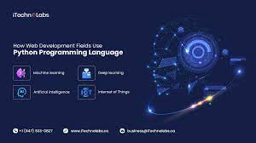

Python is a high-level, general-purpose programming language known for its readability, simplicity, and versatility. It's widely used for various tasks, including:

**Web development:** Back-end logic for websites and applications using frameworks like Flask and Django.

**Data science and machine learning:** Popular choice for data analysis, machine learning algorithms, and scientific computing due to its extensive libraries like NumPy, pandas, and scikit-learn.

**Automation and scripting:** Automating repetitive tasks, controlling systems, and interacting with APIs.

**Game development:** Used for creating 2D and 3D games with libraries like Pygame and PyOpenGL.

**Desktop applications:** Building graphical user interfaces (GUIs) with frameworks like Tkinter and PyQt.

**Here are some key features that make Python stand out:**

**Readability:** Python code uses clear syntax and indentation, making it easy to understand and write.

**Simplicity:** Beginner-friendly, with a relatively small number of keywords and constructs compared to other languages.

**Versatility:** Works across various platforms (Windows, macOS, Linux) and supports different programming paradigms like object-oriented and functional programming.

**Large community and ecosystem:** Extensive libraries and frameworks available for various tasks, along with a large and active community for support and learning.

**Open-source and free:** Freely available to use and modify, making it popular for individual and collaborative projects.

## **Flask**



Flask is a micro web framework written in Python. It is classified as a microframework because it does not require particular tools or libraries. It has no database abstraction layer, form validation, or any other components where pre-existing third-party libraries provide common functions. However, Flask supports extensions that can add application features as if they were implemented in Flask itself. Extensions exist for object-relational mappers, form validation, upload handling, various open authentication technologies and several common framework related tools.

Applications that use the Flask framework include Pinterest and LinkedIn.

**Here's a breakdown of its key features:**

**Microframework:** Provides core functionalities like URL routing, request handling, and templating, but doesn't impose specific libraries or structure. You choose the tools you need for your project.

**WSGI compliant:** Works with any WSGI server (e.g., Gunicorn, uWSGI) to handle web requests.

**Built-in development server:** Includes a simple server for development and testing.

**Templating engine:** Integrates seamlessly with Jinja2 for dynamic content generation.

**Large community and ecosystem:** Extensive documentation, tutorials, and libraries available for various functionalities.

**Common use cases for Flask:**

**REST APIs:** Building web APIs for data exchange between applications.

**Microservices:** Creating small, independent services that work together.

**Web applications:** Developing web interfaces with dynamic content and user interaction.

**Prototyping and quick experiments:** Rapidly testing ideas and functionalities.

## **HTML 5, CSS 3 and Bootstrap 5**



**HTML 5:**

HTML5 is the latest and most widely used version of the Hypertext Markup Language, the foundation of web pages. It's a markup language, meaning it uses tags to define the structure and content of a web page, rather than directly specifying how it looks.

Here's a breakdown of its key aspects:

**Semantic elements:** Introduces new tags that describe the meaning of content, like <article> for a news article or <header> for a page header. This improves accessibility and search engine optimization.

**Multimedia support:** Native integration for audio, video, and canvas elements, eliminating the need for plugins like Flash.

**Offline capabilities:** Allows web applications to store data and work even without internet connection.

**Improved forms and validation:** New input types, like <date> and <email>, and built-in validation features.

**Accessibility:** Focuses on making websites accessible to everyone, regardless of abilities.

**Responsiveness:** Designed to adapt to different screen sizes and devices, ensuring a good user experience across platforms.

**CSS 3:**

CSS3, also known as Cascading Style Sheets Level 3, isn't actually a single, unified version of CSS anymore, but rather a set of individual modules that continue to evolve and expand the capabilities of CSS. However, it's still a useful term to refer to the broader advancements and features introduced since CSS2.

**Here's a breakdown of key points about CSS3:**

**What it does:**

Styles web pages with more advanced control over layout, appearance, and animations.

**Offers features not available in previous versions, like:**

3D transformations and animations: Create complex visual effects.

Media queries: Adapt styles for different screen sizes and devices (responsive design).

Gradients and filters: Apply visual effects to elements.

Web fonts: Use custom fonts without relying on images.

Animations and transitions: Create dynamic and engaging interactions.

Flexbox and Grid: Powerful layout systems for more responsive and flexible designs.

**Bootstrap 5.0:**

Bootstrap 5.0 is the latest version of the popular front-end framework used for building responsive and mobile-first websites. Here's a breakdown of its key features:

**Key Features:**

Mobile-first: Designed for optimal performance and usability on mobile devices, with components and styles adapting seamlessly to larger screens.

Responsive: Built-in responsiveness ensures your website looks and functions well across various devices and screen sizes.

Components: Offers a wide range of pre-built components like buttons, forms, navigation bars, modals, and more, saving you development time and effort.

Utilities: Provides a set of utility classes for styling different aspects of your website like spacing, typography, colors, and more.

Customization: Highly customizable through CSS variables and themes, allowing you to tailor the framework's look and feel to your specific needs.

JavaScript: Includes optional JavaScript plugins for interactivity and advanced features like tooltips, popovers, and carousels.

Faster stylesheet: The v5.0 release boasts a smaller and faster stylesheet, improving website loading performance.

## **Jinja Templating**



Jinja is a versatile and popular templating engine widely used in Python web development, particularly with frameworks like Flask. It allows you to separate the structure and presentation of your web pages from the dynamic data, making your code cleaner, more maintainable, and easier to reuse.

**Key Features of Jinja:**

Readability: Uses Python-like syntax, making it easy to learn and understand even for beginners.

Dynamic content: Integrates variables, expressions, and control flow statements within templates for dynamic content generation.

Security: Runs templates in a sandboxed environment, preventing malicious code injection.

Extensibility: Supports custom filters, tests, and functions for advanced functionalities.

Inheritance: Allows you to create base templates with reusable layouts and content blocks, reducing code duplication.

**A simple Python Program Jinja Template use case**

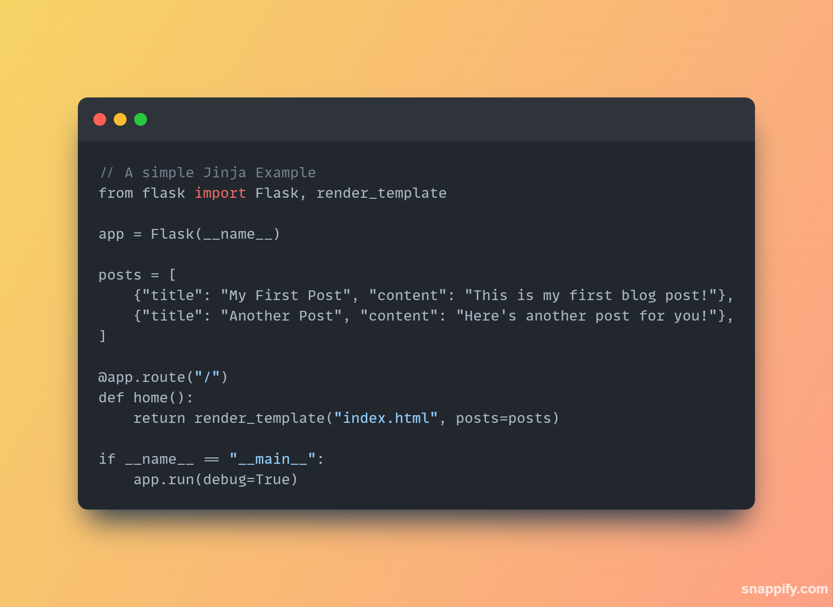 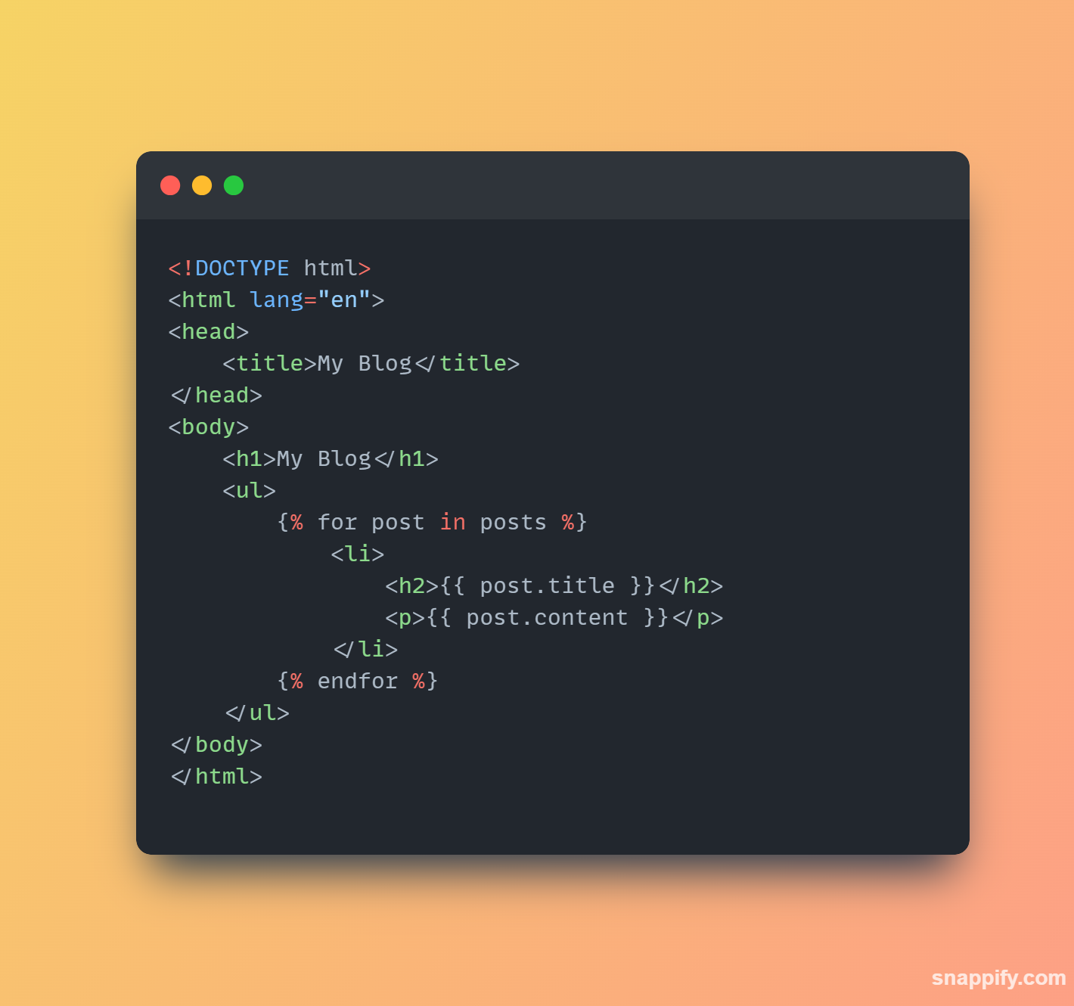

# **The Look and the Flow**

## **The Look**

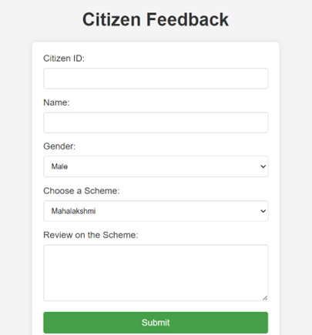

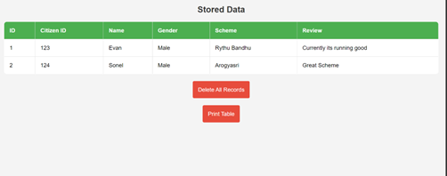

## **The Flow**

**Workflow**

**Web Interface**

**Data is Stored in Database**

**Data is Entered**

**The Data can be extracted into other forms.**

**The Data collected will be Visualized.**

# **Conclusion**

By harnessing the power of Python, Flask, HTML, CSS, and Jinja, we have successfully developed a comprehensive and accessible web interface for the Citizen Review System. This innovative platform empowers citizens to engage actively in the review process, fostering transparency and accountability within the system.

**Key achievements of this project include:**

**Enhanced Accessibility:** The web interface provides a user-friendly and intuitive experience for citizens, regardless of technical expertise. This broadens participation and ensures diverse voices are heard.

**Streamlined Review Process:** The platform facilitates a clear and efficient review process, allowing citizens to submit feedback, track progress, and share their perspectives easily.

**Increased Transparency:** Real-time information and data visualization tools within the interface promote transparency and understanding of the review process for all stakeholders.

**Improved Collaboration:** The system enables seamless communication between citizens, reviewers, and officials, fostering collaboration and informed decision-making.

**Scalability and Adaptability:** The technology stack chosen allows for future expansion and adaptation to evolving needs, ensuring the system remains relevant and effective.

Overall, this web interface represents a significant step forward in citizen engagement and democratic participation. We believe this platform will empower citizens, strengthen public trust, and contribute to a more accountable and responsive system.

# **References**

## **Official Documentations**

**Python:**

**Official Documentation:** https://docs.python.org/

**Tutorial:** https://www.learnpython.org/

**Books:**

* "Automate the Boring Stuff with Python" by Al Sweigart
* "Python Crash Course" by Eric Matthes
* "Fluent Python" by Luciano Ramalho

**Community and Forums:**

<https://www.python.org/community/forums/>

**Flask:**

**Official Documentation:** https://flask.palletsprojects.com/

**Tutorial:** https://blog.miguelgrinberg.com/post/the-flask-mega-tutorial-part-i-hello-world

**Books:**

* "Flask Web Development" by Miguel Grinberg
* "Exploring Flask" by Armin Ronacher

**Community and Forums:**

* https://support.google.com/groups/answer/2464926?hl=en
* Flask subreddit (r/flask)

**HTML:**

**Official Standard:** https://www.w3schools.com/html/

**Interactive Tutorial:** https://developer.mozilla.org/enUS/docs/Learn/HTML/Introduction_to_HTML/Getting_started

**Books:**

* "Head First HTML and CSS" by Elizabeth Robson
* "Learning Web Design" by Jennifer Niederst Robbins

**Community and Forums:** https://www.w3.org/

**CSS:**

**Official Standard:** https://developer.mozilla.org/en-US/docs/Web/CSS

**Interactive Tutorial:** https://developer.mozilla.org/en-US/docs/Learn/CSS/CSS_layout/Flexbox

**Books:**

* "Don't Make Me Think" by Steve Krug
* "Responsive Web Design" by Ethan Marcotte

**Community and Forums:** <https://cssgridgarden.com/>

**Jinja:**

**Official Documentation:** https://jinja.palletsprojects.com/

**Tutorial:**

https://palletsprojects.com/p/flask/

**Books:**

* "Flask Web Development" by Miguel Grinberg
* "Exploring Flask" by Armin Ronacher

**Community and Forums:**

Flask subreddit (r/flask)